

TRAVEL POLICY AND PROCEDURE

- Purpose
International Transport Logistics (ITL) recognizes that employee travel away from the office may be required in order to conduct company business. The purpose of this policy is to clarify requirements and procedures for the approval and reporting of business travel expenses.

B. Policy
ITL is willing to pay for or reimburse employees for actual and reasonable expenditures incurred in the course of business. It is our objective to enable an employee to live comfortably but not extravagantly while away from the office on business. It is expected that employees will use company funds with the same discretion as they would their own funds.

C. Procedure
Managers are responsible for approving travel authorizations in advance of travel and clarifying the business objectives of such travel with the employee. Upon completion of travel, an employee must complete a trip report that details what business contacts were made, the business objectives discussed, and any agreements reached. The trip report must be submitted to their manager along with their expense report.

Managers are required to review and approve all employee expense reports prior to submission to Accounts Payable. An expense report is not to be submitted without a copy of the completed trip authorization. The trip report is to be retained by the sales department as part of their client files.

In order to process reimbursement, an approved travel authorization and expense report accompanied by itemized receipts (Examples 1 & 2) must be received by Accounts Payable within 30 days of travel. Reimbursement will be issued less any travel advances within 7 days upon review by Accounts Payable and provided that all expenses are documented as required.

Example 1
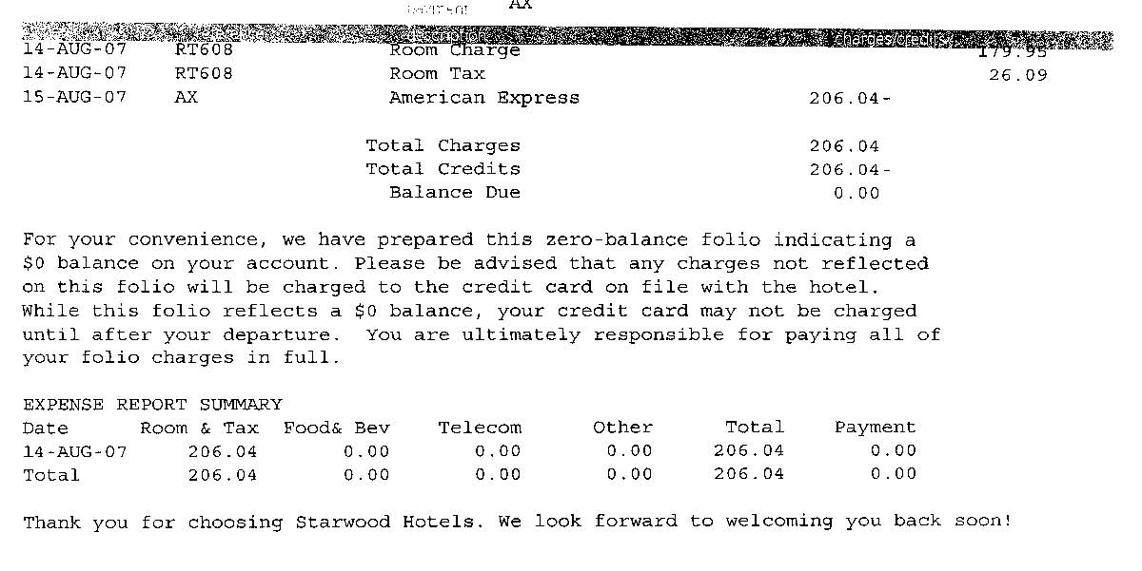
Example 2
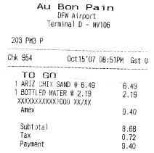

D. Airfare
ITL does not have an exclusive travel agency. All employees should do a comparison and book the lowest fare available:
- Regardless of airline preference
- As far in advance as practically possible while taking into consideration change and rebooking fees
- Traveling via coach unless approved in advance by upper management

E. Personal Vehicle
ITL will reimburse the employee for mileage when using their own personal vehicle for business purposes. Mileage is reimbursed at a rate of $0.485 per mile. Actual miles including point of origin and destination should be documented on the expense report. In the event that a company owned or provided vehicle is used for this travel, no mileage reimbursement will be made to the employee.

F. Parking Fees & Tolls
Employees are entitled to reimbursement of reasonable vehicle parking charges assessed at the airport and tolls incurred due to company travel.

G. Rental Car
ITL will reimburse employees for charges associated with renting a vehicle while out of town on company business when it is less than the cost of other available transportation (taxis, shuttles, etc.) It is expected that employees will select the most economical vehicle to suit the needs of the trip.

Applicable guidelines that will apply include but are not limited to:
- Employees will be reimbursed for the Standard vehicle class rate as set forth by the rental agency or the Intermediate if the circumstances surrounding travel deem a larger capacity vehicle. An upgrade must be approved prior to travel.
- Vehicles must be returned to the same rental location unless specifically approved by management in advance of the trip.
- Vehicles must be refueled prior to return to the rental location. Fuel costs are reimbursed when a receipt accompanies the employee’s expense report.
- Fines and traffic violations are the responsibility of the violator.

H. Lodging
ITL will reimburse the employee for reasonable and customary lodging expenses for the required number of days allotted for travel. It is expected that the employee will select a facility that is reasonably close to the location at which they will be doing business. However, the room rate charged shall not be an excessive rate, which will be determined based on a survey of nearby hotels in the market and agreed to by the management.

I. Meals
ITL will reimburse each employee up to a rate of $40 per day for meals. Receipts will be required for all meal expenses and only up to $40 will be reimbursed. Meals as part of entertainment expenses will be taken into consideration when determining the amount reimbursable.

J. Entertainment
In some instances, ITL and its employees to pick-up meal and/or entertainment expenses in order to discuss new business and/or to maintain existing clients.

NOTE: Employees are NOT expected nor encouraged to pay for meals or entertainment expenses for ITL vendors or suppliers. This shall NOT apply when prior authorization has been granted by their manager to cover such expenses.

In order to make the most efficient use of these business resources, the following guidelines will apply:
- Each employee is expected to use appropriate judgment in providing for customer meals and entertainment while on company business.
- Only meals and entertainment for the employee and client are reimbursable.
- Existing or prospective customers that request the employee to provide entertainment that would result in an unfavorable image to ITL or the employee should be respectfully declined.
- When providing for meals and/or entertainment to existing or prospective customers, discretion must be used by the employee prior to making the expense. This may include, but is not limited to:
  - The excessive purchase of alcoholic beverages for the consumption by the employee and/or customer.
  - The selection of an appropriately priced venue to provide such meals.
- Entertainment expense documentation must include the receipt, the individuals entertained and the business purpose.

- Business Gifts
Business gifts for vendors or clients, other than our branded merchandise, must be approved in advance by upper management.

L. Travel Duration Guidelines:
The following guidelines will be considered when planning any business trip in duration of more than two days:

- Departure and return times should be scheduled in advance to reduce the amount of time away from the office yet meeting the physical needs of the employee.
- Unless absolutely necessary, employees should refrain from scheduling an early morning appointment out of town that would require an initial overnight stay unless other travel arrangements are unavailable.

NOTE: Employees may choose to extend their travel for personal pleasure at their own expense.

M. Corporate Credit Card
Employees that are issued company credit cards must adhere to the following guidelines for continued use of such cards:

- Only business-related expenses are authorized to be charged to the company account. Personal expenses are prohibited unless approved in advance by upper management.
- A copy of the monthly statement will be provided to each cardholder. All original receipts along with a thorough explanation of the expense must be submitted to Accounts Payable. Cardholders are responsible for all charges incurred on their corporate credit card.
  - Expenses directly related to a customer’s job must be clearly identified and approved prior to incurrence.

N. Exclusions
- Personal grooming items
- Magazines, periodicals, books except for those required for company business
- Flight insurance
- Loss of personal items
- Damages to personal vehicle
- Fines & traffic violations
- ATM fees
- Laundry
- Movies
- Health club facilities
- Unreasonable tips

The company recognizes that there will be times that deviation from the aforementioned policy and guidelines may be appropriate. When an extraordinary situation arises, the employee should feel free to present the request to his/her manager in order to reach a mutual agreement that is in the best interest of both the company and employee.

O. Required Forms
- Travel Authorization Form
- Travel Expense Report
- Trip Report

